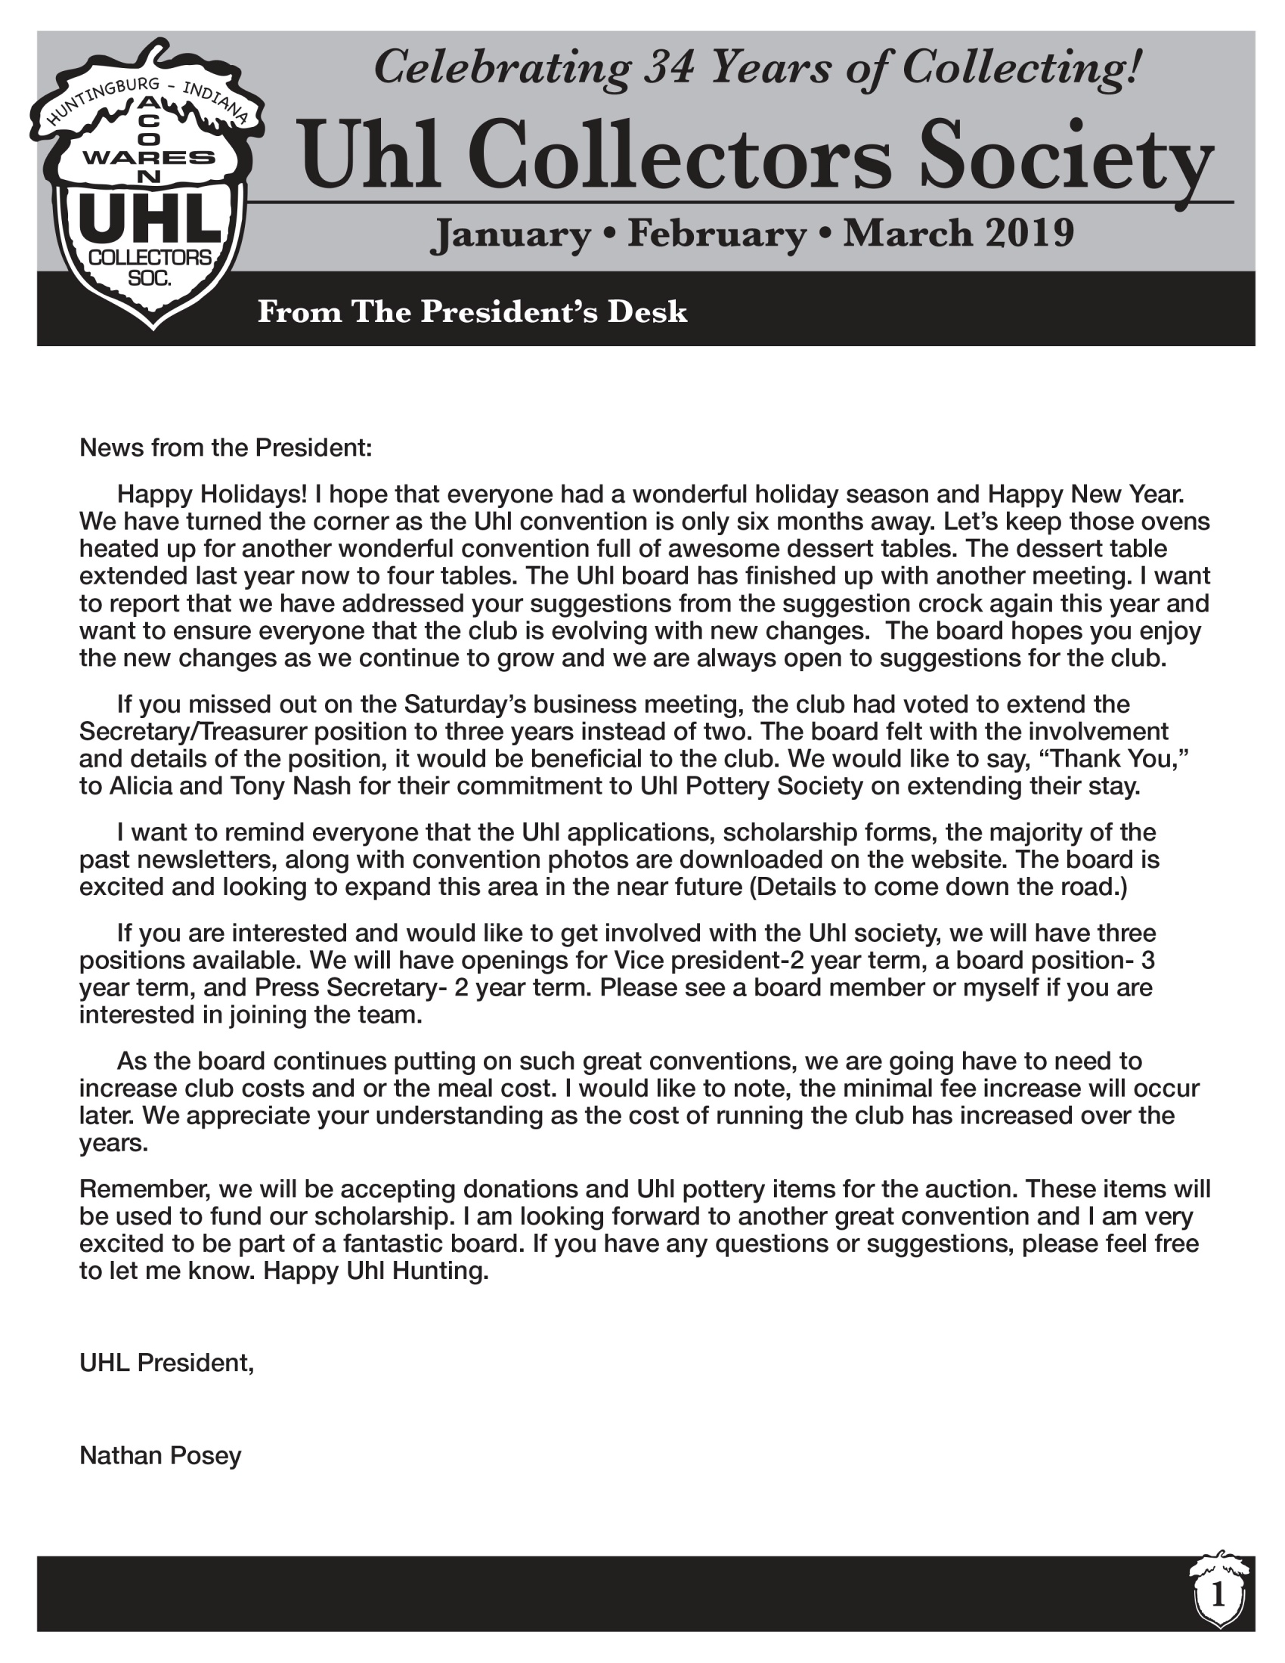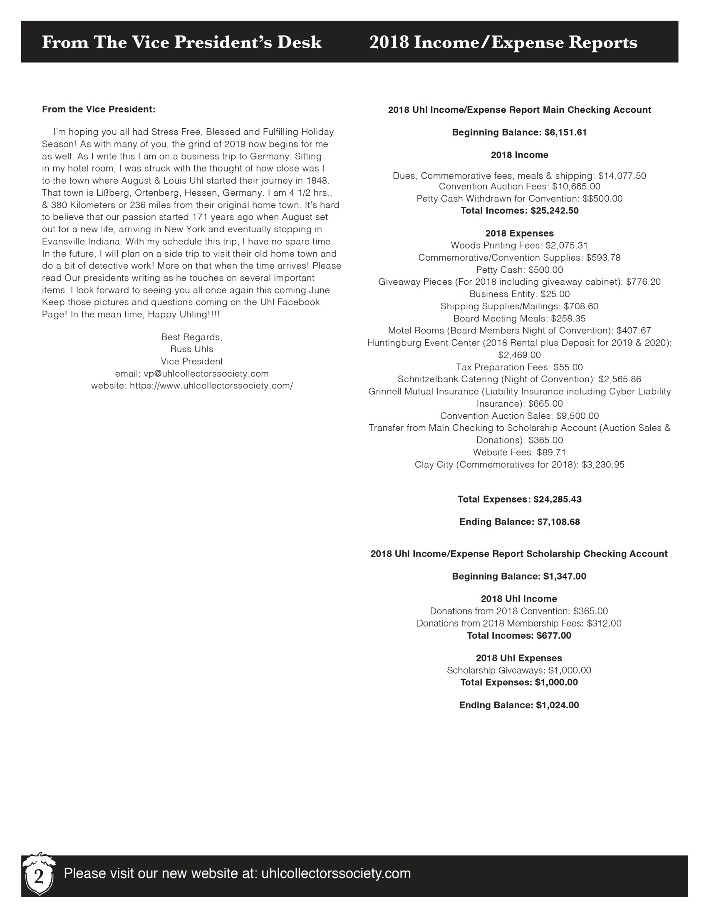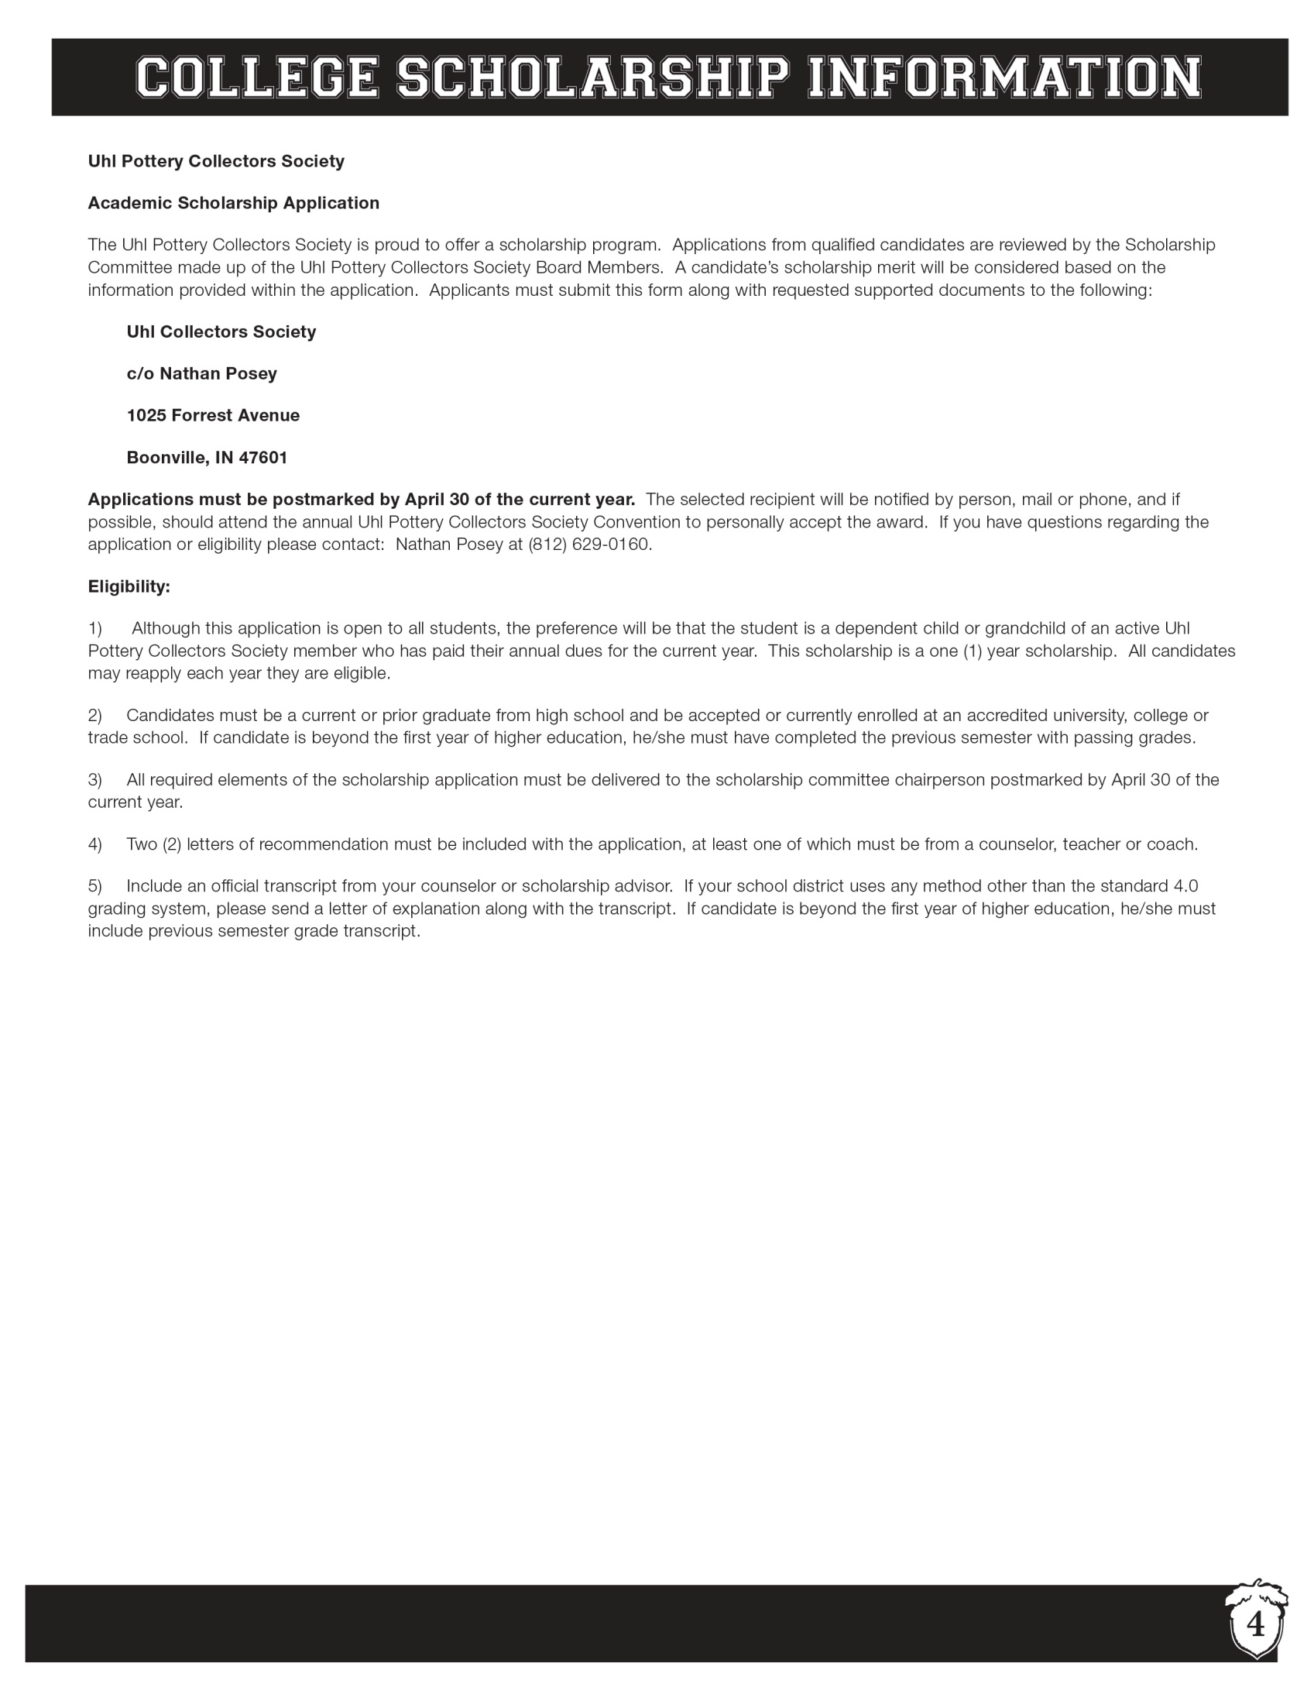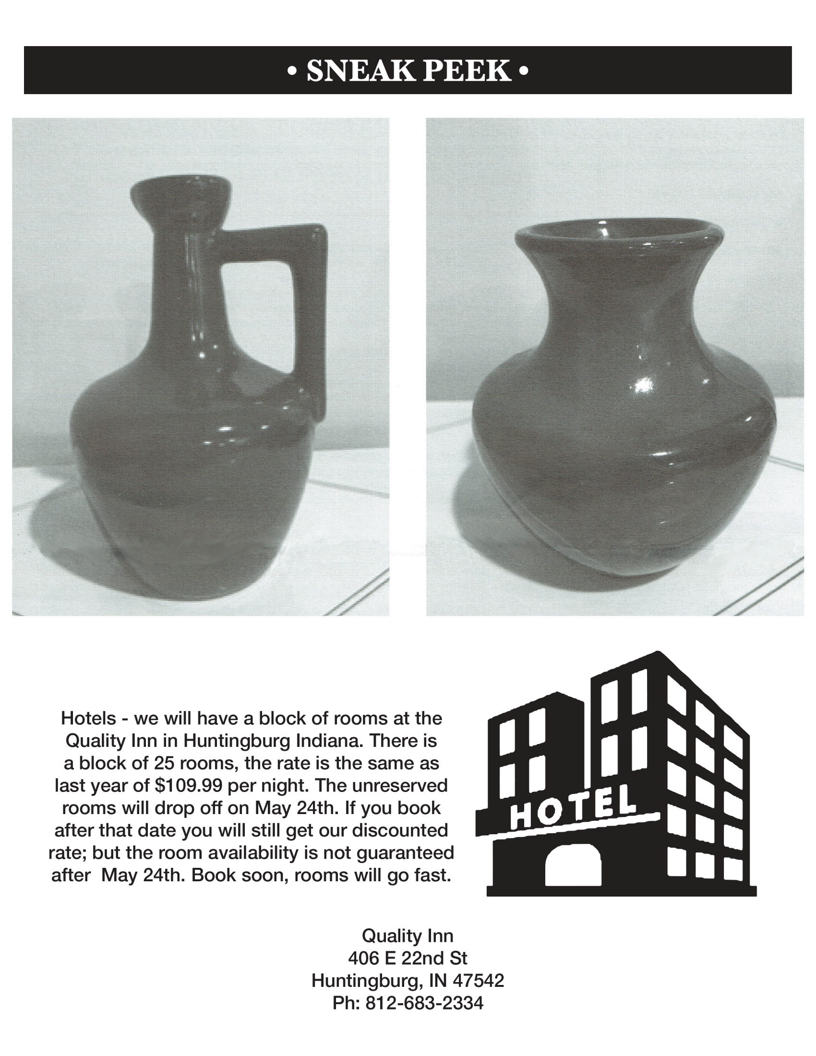
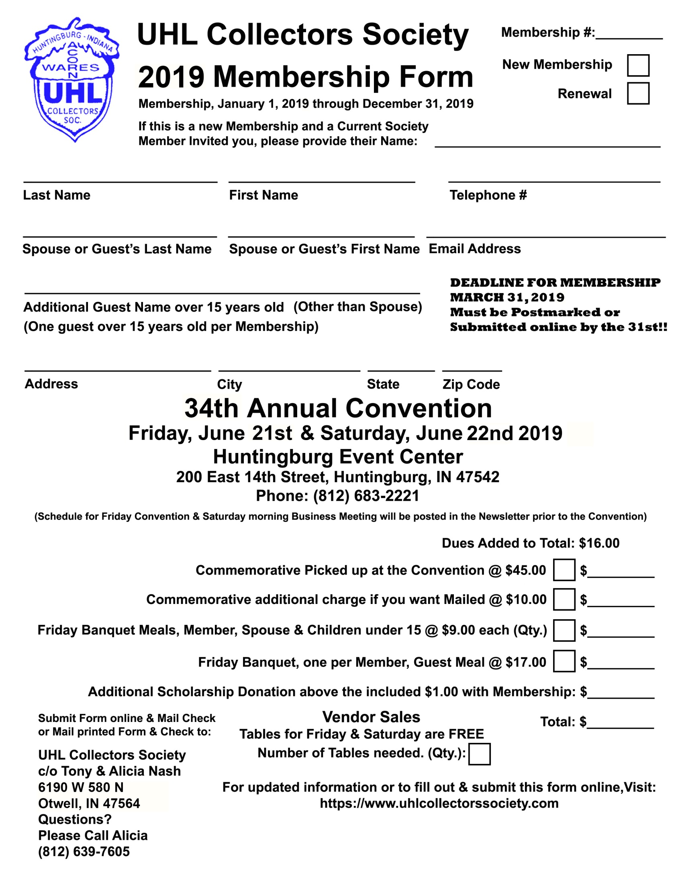
Uhl Pottery Collectors Society
Academic Scholarship Application
The Uhl Pottery Collectors Society is proud to offer a scholarship program. Applications from qualified candidates are reviewed by the Scholarship Committee made up of the Uhl Pottery Collectors Society Board Members. A candidate’s scholarship merit will be considered based on the information provided within the application. Applicants must submit this form along with requested supported documents to the following:
Uhl Collectors Society
c/o Alicia Nash
6190 W 580 N
Otwell, IN 47564

Applications must be postmarked by April 30 of the current year. The selected recipient will be notified by person, mail or phone, and if possible, should attend the annual Uhl Pottery Collectors Society Convention to personally accept the award. If you have questions regarding the application or eligibility please contact: Nathan Posey at (812) 629-0160.
Eligibility:
- Due to the overwhelming amount of extremely talented and worthy applicants and our financial inability to award a scholarship to all those who apply, we must invoke an application time frame clause. If you received a scholarship award in the past, you will be ineligible to re-apply for a period of 2 years. This was a difficult decision to make, but in fairness to those who did not receive a scholarship the previous year, we must implement this.

- Although this application is open to all students, the preference will be that the student is a dependent child or grandchild of an active Uhl Pottery Collectors Society member who has paid their annual dues for the current year. This scholarship is a one (1) year scholarship. All candidates may reapply each year they are eligible.

- Candidates must be a current or prior graduate from high school and be accepted or currently enrolled at an accredited university, college or trade school. If candidate is beyond the first year of higher education, he/she must have completed the previous semester with passing grades.

- All required elements of the scholarship application must be delivered to the scholarship committee chairperson postmarked by April 30 of the current year.

- Two (2) letters of recommendation must be included with the application, at least one of which must be from a counselor, teacher or coach.

- Include an official transcript from your counselor or scholarship advisor. If your school district uses any method other than the standard 4.0 grading system, please send a letter of explanation along with the transcript. If candidate is beyond the first year of higher education, he/she must include previous semester grade transcript.

Uhl Pottery Collectors Society
Academic Scholarship Application
Instructions: type or print off computer and return to the Scholarship Committee before deadline.
Last Name: First Name: Middle Initial:
Date of Birth: Male Female
Home Address:
City/State/Zip:
Email Address: Telephone:
Uhl Pottery Club Member: Relationship:
High School Data:
1st Generation College Student: Yes No
Class Rank: Class Size: G.P.A.: On a scale of: SAT score:
As of this date, do you have a tuition package that pays more than half of your college tuition per year?
Post High School Data:
School you are planning to attend:
Have you been accepted or currently enrolled? Yes No
Enrollment Status: Full-time Part-time
Indicate Housing Plans: On Campus Off Campus Will Commute
Major Field of College Study:
Describe any paid work experience during the past four years:
Describe all extracurricular, community and church activities that you have participated in during the past four years. Indicate special awards/honors. Attach separate pages if needed.

Personal Essay:
In 500 words or less, explain what you hope to accomplish in your lifetime.

In signing this application, I hereby certify that the information is complete and accurate to the best of my knowledge. My signature indicates permission to use my name in any promotional material by the Uhl Pottery Collectors Society and to release all personal and academic records to the scholarship committee.

_____________________________________ ____________________________________
Applicants Signature Parent’s or Guardian’s Signature
Date of Application:

